NESTLE PAKISTAN Real Annual Report Analysis

STEP 1
Downloaded the Financial Report of Nestle Pakistan 2025

STEP 2

hand-calculated ratios
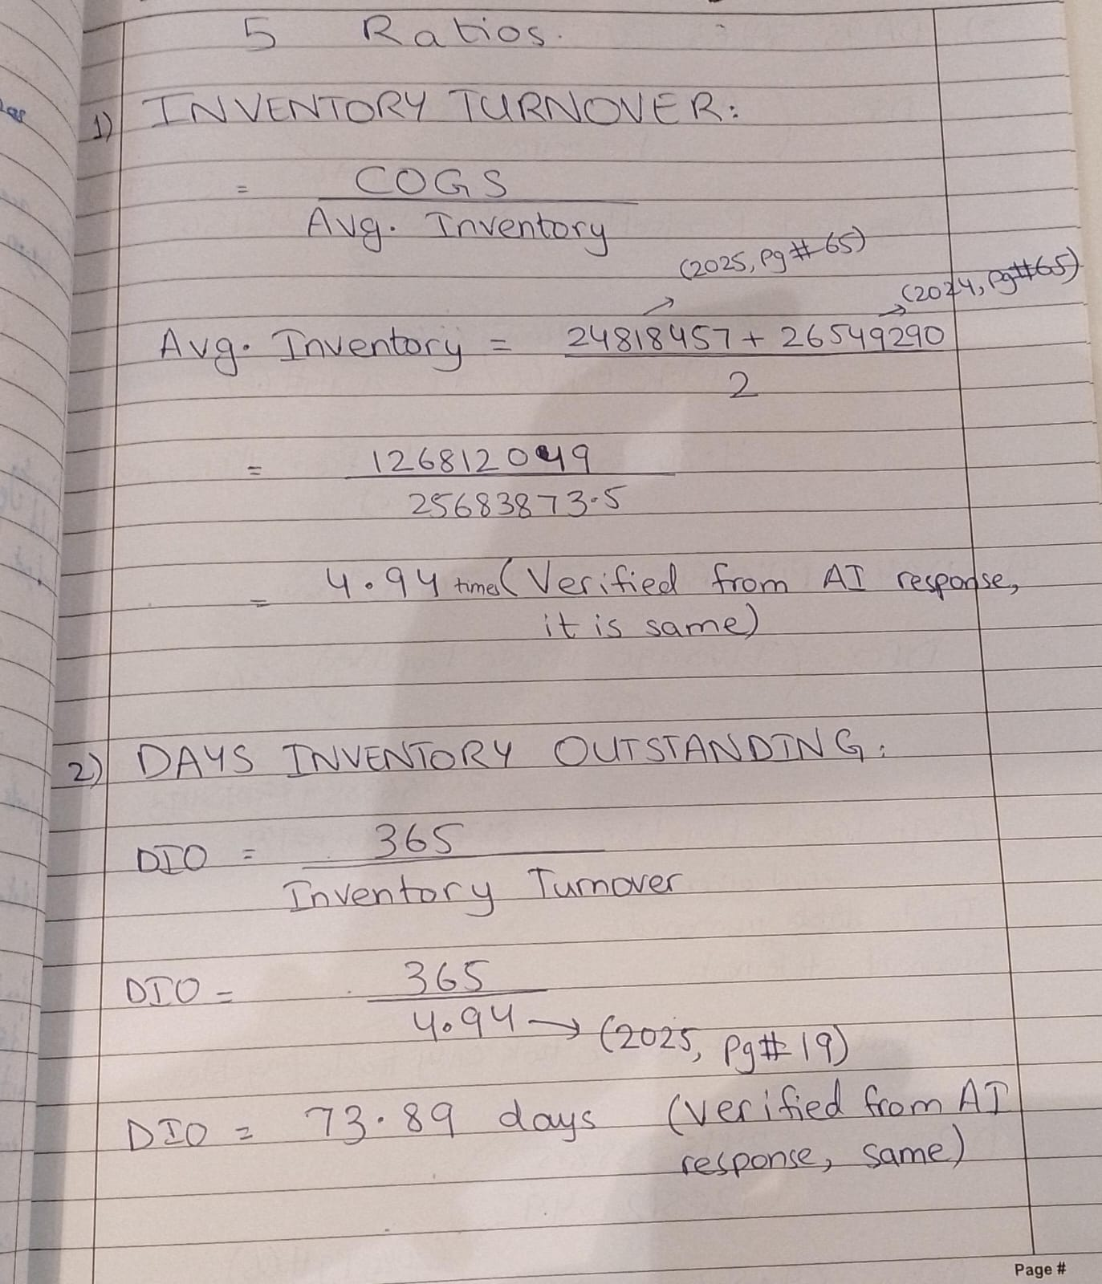
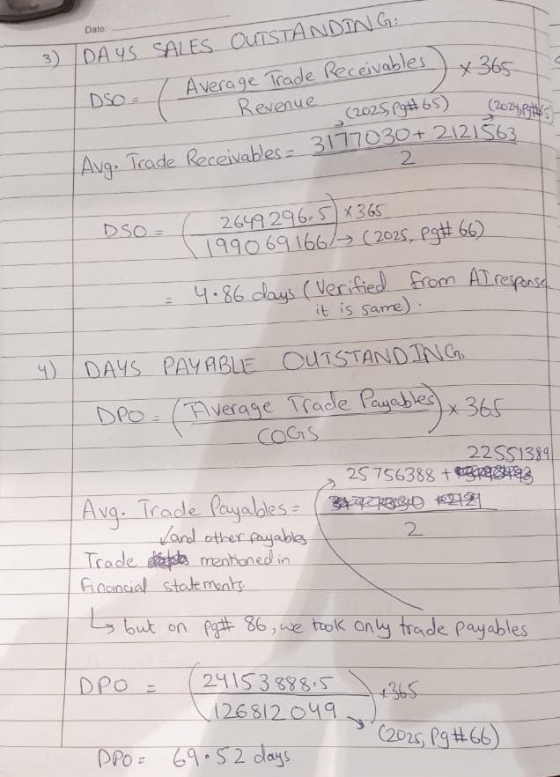
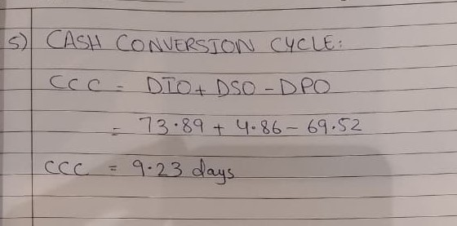

STEP 3

The AI Prompt Log for your structuring prompt, plus the AI's structured output table
PROMPT:
I am a BBA student in a Supply Chain Analytics course, working with REAL financial data from Nestle Pakistan's annual report (a company listed on the Pakistan Stock Exchange).
I am going to paste the actual text of their Income Statement, Balance Sheet, and Cash Flow Statement below. Your only job is to organize the numbers I give you into a clean table — DO NOT estimate, infer, calculate, or fill in any figure I have not explicitly provided.
If a figure I ask for is not present in what I pasted, write "Not provided" — never guess or approximate it.
Organize the output as a table with these columns:
Year | Statement | Line Item | Value (PKR) | Notes
Extract these line items specifically, where available: Revenue, Cost of Goods Sold, Gross Profit, Inventory, Trade Receivables, Trade Payables, Capital Expenditure, and Segment/Geographic Revenue breakdown if disclosed.
Here is the pasted financial statement text:
STATEMENT OF PROFIT OR LOSS For the year ended December 31, 2025 (Rupees in 000) Note 2025 2024 Revenue from contracts with customers – net 27 199,069,166 193,205,756 Cost of goods sold 28 (126,812,049) (123,681,762) Gross profit 72,257,117 69,523,994 Distribution and selling expenses 29 (33,610,875) (32,973,536) Administration expenses 30 (6,524,932) (7,001,233) Operating profit 32,121,310 29,549,225 Finance cost 31 (570,217) (2,589,499) Other expenses 32 (3,035,404) (2,071,201) (3,605,621) (4,660,700) Other income 33 1,165,439 615,611 Profit before final tax, minimum tax differential and income tax 29,681,128 25,504,136 Final tax 34 – (24,785) Minimum tax differential 34 – (199,104) Profit before income tax 29,681,128 25,280,247 Income tax 34 (12,437,207) (10,472,276) Profit after taxation 17,243,921 14,807,971 Earnings per share basic and diluted (Rupees) 35 380.24 326.53 The annexed notes 1 to 50 form an integral part of these financial statements.
STATEMENT OF COMPREHENSIVE INCOME For the year ended December 31, 2025 (Rupees in 000) 2025 2024 Profit after taxation 17,243,921 14,807,971 Other comprehensive income Items that may be reclassified subsequently to profit or loss (net of tax) – – Items that will not be reclassified subsequently to profit or loss (net of tax) Remeasurement gain on net long–term employee benefit liability 636,163 304,501 Related tax (184,289) (88,305) 451,874 216,196 Other comprehensive income for the year 451,874 216,196 Total comprehensive income for the year 17,695,795 15,024,167 The annexed notes 1 to 50 form an integral part of these financial statements.
STATEMENT OF CASH FLOWS For the year ended December 31, 2025 (Rupees in 000) Note 2025 2024 Cash flow from operating activities Profit before taxation 29,681,128 25,280,247 Adjustment for non–cash charges and other items: Depreciation of property, plant and equipment 16.4 4,348,393 3,974,702 Amortization of intangible assets 18 18,835 544 Impairment charge / (reversal) – net 32 & 33 427,093 (20,277) Gain on disposal of property, plant and equipment – owned 33 (227,489) (70,544) (Gain) / loss on termination of lease 33 & 32 (20,546) 50 Provision for Workers’ Profit Participation Fund 32 1,521,167 1,303,641 Provision for Workers’ Welfare Fund 32 741,176 576,254 Increase in provision for stores and spares 21.1 215,654 475,477 Reversal of provision for stock in trade – net 22.1 (311,476) (519,036) Allowance for expected credit losses 33 – (1,570) Exchange gain unrealized 32 (169,562) (47,071) Final tax and minimum tax differential 34 – 223,889 Provision for defined benefits plans 7.10 1,908,614 2,893,104 Finance cost 31 570,217 2,589,499 Profit before working capital changes 38,703,204 36,658,909 Effect on cash flow due to working capital changes: (Increase) / decrease in current assets: Stores and spares (124,505) (910,080) Stock–in–trade 2,042,309 7,408,230 Trade debts (1,055,467) 112,618 Advances, deposits, prepayments and other receivables (756,525) 2,531,179 Sales tax recoverable 2,406,734 8,838,563 Increase / (decrease) in current liabilities: Trade and other payables 8,616,327 (5,081,846) Contract liabilities (168,517) 311,026 10,960,356 13,209,690 Cash generated from operations 49,663,560 49,868,599 (Increase) / decrease in long term loans – net (355,068) 19,928 Increase in customer security deposits – interest free 105,939 92,831 Contributions by the Company – net (954,877) (667,292) Workers’ Profit Participation Fund paid 11.3 (1,297,349) (1,420,562) Workers’ Welfare Fund paid 11.4 (594,785) (648,422) Finance cost paid (752,671) (2,876,071) Final tax and minimum tax differential paid – (223,889) Income taxes paid (10,885,771) (12,764,635) Net cash generated from operating activities 34,928,978 31,380,487 (Rupees in 000) Note 2025 2024 Cash flow from investing activities Purchase of property, plant and equipment (5,024,366) (4,402,187) Purchase of short–term investments (9,588,794) – Sale proceeds from disposal of property, plant and equipment 16.6 324,847 91,704 Net cash used in investing activities (14,288,313) (4,310,483) Cash flow from financing activities Long–term loans repaid (3,000,000) (3,500,000) Short–term borrowings obtained 1,800,000 17,300,000 Short–term borrowings repaid (2,000,000) (22,600,000) Principal portion of lease liabilities paid (197,968) (125,849) Dividends paid (14,996,152) (14,544,017) Net cash used in financing activities (18,394,120) (23,469,866) Net increase in cash and cash equivalents 2,246,545 3,600,138 Cash and cash equivalents at beginning of the year 1,661,851 (1,938,287) Cash and cash equivalents at end of the year 38 3,908,396 1,661,851 The annexed notes 1 to 50 form an integral part of these financial statements
STATEMENT OF FINANCIAL POSITION As at December 31, 2025 (Rupees in 000) Note 2025 2024 EQUITY AND LIABILITIES Share capital and reserves Authorized capital 75,000,000 (2024: 75,000,000) ordinary shares of PKR 10 each 750,000 750,000 Issued, subscribed and paid up capital 3 453,496 453,496 Share premium – capital reserve 4 249,527 249,527 General reserve – revenue reserve 280,000 280,000 Accumulated profits – revenue reserve 20,285,092 17,600,015 21,268,115 18,583,038 Non–current liabilities Long–term finances – secured 5 – 1,420,350 Lease liabilities 6 1,326,275 1,434,907 Long–term employee benefits 7 5,532,046 5,030,182 6,858,321 7,885,439 Current liabilities Current portion of long–term liabilities 8 1,907,694 3,129,449 Short–term borrowings – secured 9 – 200,000 Running finance under mark–up arrangements – secured 10 – 660,550 Trade and other payables 11 60,335,267 51,542,606 Contract liabilities 12 850,973 1,019,490 Income tax payable 2,126,681 – Interest and mark–up accrued 13 956 183,410 Customer security deposits 14 440,742 334,804 Unclaimed dividend 104,647 90,081 65,766,960 57,160,390 Contingencies and commitments 15 93,893,396 83,628,867 (Rupees in 000) Note 2025 2024 ASSETS Non–current assets Property, plant and equipment 16 30,131,584 29,407,234 Capital work–in–progress 17 2,526,967 2,754,932 Intangible assets 18 95,541 15,775 Deferred taxation 19 4,658,016 3,370,938 Long–term loans 20 583,462 256,939 37,995,570 35,805,818 Current assets Current portion of long–term loans 20 172,020 143,475 Stores and spares 21 4,355,163 4,446,312 Stock–in–trade 22 24,818,457 26,549,290 Trade debts 23 3,177,030 2,121,563 Sales tax recoverable 5,923,212 8,329,946 Income tax recoverable – 711,833 Advances, deposits, prepayments and other receivables 24 3,954,754 3,198,229 Short–term investments 25 9,588,794 – Cash and bank balances 26 3,908,396 2,322,401 55,897,826 47,823,049 93,893,396 83,628,867
At the end, list any line item I asked about that was NOT found in what I pasted.
AI STRUCTURED OUTPUT TABLE:
Year | Statement | Line Item | Value (PKR '000) | Notes
2025 | Income Statement | Revenue | 199,069,166 | "Revenue from contracts with customers – net"
2024 | Income Statement | Revenue | 193,205,756 | "Revenue from contracts with customers – net"
2025 | Income Statement | Cost of Goods Sold | (126,812,049) | Shown as negative/deduction in statement
2024 | Income Statement | Cost of Goods Sold | (123,681,762) | Shown as negative/deduction in statement
2025 | Income Statement | Gross Profit | 72,257,117 | —
2024 | Income Statement | Gross Profit | 69,523,994 | —
2025 | Balance Sheet | Inventory | 24,818,457 | Labeled "Stock–in–trade"
2024 | Balance Sheet | Inventory | 26,549,290 | Labeled "Stock–in–trade"
2025 | Balance Sheet | Trade Receivables | 3,177,030 | Labeled "Trade debts"
2024 | Balance Sheet | Trade Receivables | 2,121,563 | Labeled "Trade debts"
2025 | Balance Sheet | Trade Payables | 60,335,267 | Labeled "Trade and other payables" (includes "other payables," not isolated to trade payables alone)
2024 | Balance Sheet | Trade Payables | 51,542,606 | Labeled "Trade and other payables" (includes "other payables," not isolated to trade payables alone)
2025 | Cash Flow Statement | Capital Expenditure | (5,024,366) | Labeled "Purchase of property, plant and equipment," under investing activities
2024 | Cash Flow Statement | Capital Expenditure | (4,402,187) | Labeled "Purchase of property, plant and equipment," under investing activities
2025 | — | Segment/Geographic Revenue breakdown | Not provided | No breakdown appeared in pasted text
2024 | — | Segment/Geographic Revenue breakdown | Not provided | No breakdown appeared in pasted text

STEP 4

Verification Checklist, with page numbers noted against every extracted figure
Additional Prompt:
“Add another coloumn and also mention the pages number from where you extracted these values”
REFLECTION:
The extracted values were consistent with the AI output. However, I manually verified and added the annual report page numbers because the AI did not provide page-level references.
Year | Statement | Line Item | Value (PKR '000) | Notes | Report Page Number
2025 | Income Statement | Revenue | 199,069,166 | "Revenue from contracts with customers – net" | 66
2024 | Income Statement | Revenue | 193,205,756 | "Revenue from contracts with customers – net" | 66
2025 | Income Statement | Cost of Goods Sold | (126,812,049) | Shown as negative/deduction in statement | 66
2024 | Income Statement | Cost of Goods Sold | (123,681,762) | Shown as negative/deduction in statement | 66
2025 | Income Statement | Gross Profit | 72,257,117 | — | 66
2024 | Income Statement | Gross Profit | 69,523,994 | — | 66
2025 | Balance Sheet | Inventory | 24,818,457 | Labeled "Stock–in–trade" | 65
2024 | Balance Sheet | Inventory | 26,549,290 | Labeled "Stock–in–trade" | 65
2025 | Balance Sheet | Trade Receivables | 3,177,030 | Labeled "Trade debts" | 65
2024 | Balance Sheet | Trade Receivables | 2,121,563 | Labeled "Trade debts" | 65
2025 | Balance Sheet | Trade Payables | 60,335,267 | Labeled "Trade and other payables" (includes "other payables," not isolated to trade payables alone) | 64
2024 | Balance Sheet | Trade Payables | 51,542,606 | Labeled "Trade and other payables" (includes "other payables," not isolated to trade payables alone) | 64
2025 | Cash Flow Statement | Capital Expenditure | (5,024,366) | Labeled "Purchase of property, plant and equipment," under investing activities | 70
2024 | Cash Flow Statement | Capital Expenditure | (4,402,187) | Labeled "Purchase of property, plant and equipment," under investing activities | 70
2025 | — | Segment/Geographic Revenue breakdown | Not provided | No breakdown appeared in pasted text | Not provided
2024 | — | Segment/Geographic Revenue breakdown | Not provided | No breakdown appeared in pasted text | Not provided

STEP 5

AI's independently calculated ratios
2025 Calculations (using average of 2024 & 2025 balances)
Inputs:
- COGS (2025) = 126,812,049
- Revenue (2025) = 199,069,166
- Average Inventory = (24,818,457 + 26,549,290) ÷ 2 = 25,683,873.5
- Average Trade Receivables = (3,177,030 + 2,121,563) ÷ 2 = 2,649,296.5
- Average Trade Payables = (60,335,267 + 51,542,606) ÷ 2 = 55,938,936.5
Calculations:
- Inventory Turnover = 126,812,049 ÷ 25,683,873.5 = 4.94x
- DIO = 365 ÷ 4.94 = 73.87 days
(Check: 25,683,873.5 ÷ 126,812,049 × 365 = 73.94 days — small rounding difference depending on where you round; use the direct formula 25,683,873.5 ÷ 126,812,049 × 365 for precision = 73.94 days)
- DSO = (2,649,296.5 ÷ 199,069,166) × 365 = 4.86 days
- DPO = (55,938,936.5 ÷ 126,812,049) × 365 = 161.03 days
⚠️ Note: this uses "Trade and other payables," not isolated trade payables — so DPO here is inflated relative to a "pure" trade payables DPO.
- CCC = 73.94 + 4.86 − 161.03 = −82.23 days

Comparison Table
Metric | My Earlier Value | Your Hand Calculation | Match?
Avg. Inventory | 25,683,873.5 | 25,683,873.5 | ✅ Match
Inventory Turnover | 4.94x | 4.94x | ✅ Match
DIO | 73.94 days | 73.89 days | ⚠️ Minor discrepancy
Avg. Trade Receivables | 2,649,296.5 | 2,649,296.5 | ✅ Match
DSO | 4.86 days | 4.86 days | ✅ Match
Avg. Trade Payables | 55,938,936.5 | 28,756,388 (per your page-86 figure) | ❌ Real discrepancy — different inputs used
DPO | 161.03 days | 69.52 days | ❌ Large discrepancy — driven by the input difference above
CCC | −82.23 days | 9.23 days | ❌ Large discrepancy — cascades from DPO

Reflection on discrepancies
1. DIO: 73.94 vs. 73.89 — resolved, not a real error.
This is just rounding propagation. I divided 365 by the rounded turnover figure (4.94), which compounds rounding error. You (and my more precise recomputation) get 73.94 days when dividing average inventory by COGS directly and multiplying by 365, without rounding turnover first. The "true" answer is 73.94 days — carry full precision through intermediate steps, only round the final answer. This is a 0.05-day difference and immaterial for your purposes, but worth noting for methodology.
2. Trade Payables: this is the real issue.
You wrote that "on pg# 86, we took only trade payables" and used 28,756,388 and 22,551,389 (partially obscured in your photo) to get an average of what appears to be a smaller, isolated trade payables figure — separate from "other payables."
I never had access to page 86 or Note 11's breakdown. My table explicitly flagged this limitation: I used 60,335,267 (2025) and 51,542,606 (2024), labeled clearly as "Trade and other payables" — the combined balance sheet line — because that was the only figure available in the text you'd pasted at that point. I did not have the note-level split between "trade payables" and "other payables."
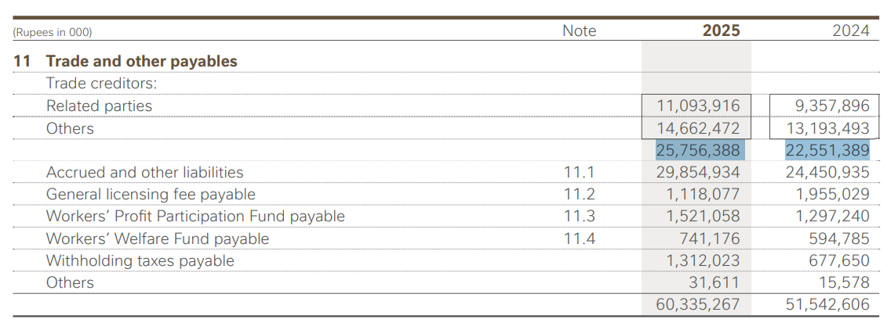
This means your DPO and CCC are almost certainly more accurate than mine, because you're using the correct, isolated trade payables figure that actually corresponds to purchases/COGS — which is the theoretically correct DPO input. Mixing in "other payables" (accrued expenses, tax payables, etc.) artificially inflates DPO, which is exactly what happened in my calculation (161 days is implausibly high for a company that reports strong receivables/inventory efficiency).
How to resolve it for your submission: Use your DPO and CCC (69.52 days and 9.23 days) as the final answer, and note in your write-up that the AI's initial figure used the combined "trade and other payables" balance sheet line because that was the only data supplied to it, while your hand calculation correctly isolated trade payables from Note 11 on page 86 — producing a more economically meaningful DPO and CCC. A CCC of +9.23 days is also far more plausible for a company like Nestlé Pakistan than a negative 82 days, so your corrected inputs make the result more sensible on its face, not just more "correct" on a technicality.

Short (150-200 word) Reflection
Nestlé Pakistan's Cash Conversion Cycle of 9.23 days tells a fairly healthy working-capital story, though not an extreme one.
Breaking it down: the company holds inventory for about 74 days (DIO) before selling it, and collects cash from customers in just 4.86 days (DSO) — an unusually short collection period, the low DSO indicates that Nestlé Pakistan converts its receivables into cash relatively quickly, reducing the time capital remains tied up in customer balances.. On the other side, the company takes about 69.5 days (DPO) to pay its own suppliers.
Because DPO nearly offsets DIO, the company only has to fund its own operations out of pocket for roughly 9 days between paying suppliers and receiving cash from customers — a very short working-capital funding gap. This means Nestlé Pakistan is largely financing its inventory using supplier credit rather than its own cash, which is efficient and reduces reliance on short-term borrowing.
Compared to my earlier (incorrect) calculation using the combined "trade and other payables" figure — which produced a negative CCC of −82 days — the corrected, isolated trade payables figure gives a far more realistic and interpretable picture of the company's true operating cash cycle.
Final verified 2025 ratios:
- Inventory Turnover = 4.94×
- DIO = 73.89 days
- DSO = 4.86 days
- DPO = 69.52 days
- CCC = 9.23 days.

Chat History of Claude AI:
https://claude.ai/share/1c65e102-9883-4263-a3f2-23f41c6823f3

